# Concentric Circles

French nobleman Georges Louis Leclerc, Comte de Buffon was one of the first scholars to explore the area of mathematics known as geometric probability. In 1733 during a lecture at the Royal Academy of Sciences in Paris, he posed his famous needle problem which asked:

Suppose that you drop a needle of length $l$ on ruled paper with lines at a constant interval $d$—what is then the probability that the needle comes to lie in a position where it crosses one of the lines?[1]

Since then, many variations to the needle problem have been proposed and solved such as one where parallel lines are replaced with concentric circles:

What is the probability a needle of length $l$ will cross a circumference when dropped on a set of $N$ concentric circles, given that each circle’s radius varies by a constant amount $d$ and $l≤d$?

The method that I use to solve this problem is based on one devised by Harry J. Khamis.[2] First, let us establish a few definitions for clarity.

*Position -* the needle is assumed to be a one-dimensional line segment. Its position is the midpoint this line. Denoted $M$.

*Separation distance -* the shortest distance between the closest circumference and the position of the needle. It is equal to the length of the line normal to the circumference that also passes through $M$. Denoted $x$.

*Orientation -* refers to the smaller of the two angles formed between the needle and the line segment representing separation distance. Denoted $θ$ and $0≤θ≤\frac{π}{2}$.

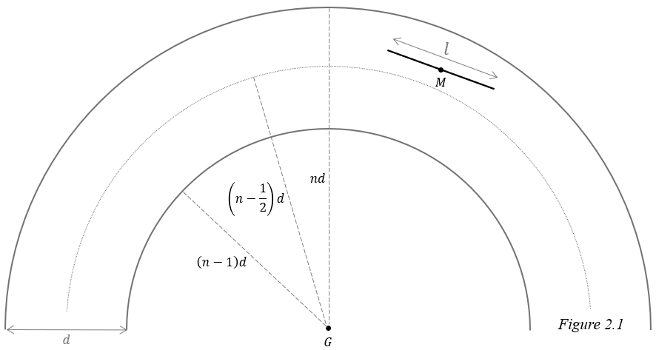Second, we will assume $M$ falls at a random spot, $θ$ is random, and the two are independent of each other. We define the center of the circles to be point $G$, and say that the needle falls within the $n^{th}$ annulus with inner radius $\left(n-1\right)d$ and outer radius $nd$.

We will first look at only one annulus and consider the probability a needle crosses either circumference. From the perspective of the needle, the inner circumference is convex while the outer is concave. This difference means the scenario where the needle crosses the outer circumference must be approached differently than the scenario where it crosses the inner circumference. As such, we will separate the problem into two cases.

*Case 1*: The needle falls in the outer half of the $n^{th}$ annulus. Call this event $K_{n}$.

$$\left(n-\frac{1}{2}\right)d<\overline{GM}≤nd, n=1, 2, 3, …,N$$

*Case 2*: The needle falls in the inner half of the $n^{th}$ annulus. Call this event ${K^{'}}_{n}$.

$$\left(n-1\right)d<\overline{GM}≤\left(n-\frac{1}{2}\right)d, n=2, 3, 4, …, N$$

## Case 1

One important difference from the classic needle problem is that the pdf of $x$ is not uniform. This becomes clear if we imagine a circle divided into several annuli. The outermost annulus has the greatest area and since it is assumed the needle is equally likely to land at each point on the circle, it is most likely to land in the outermost annulus. By the same logic, it is least likely to land in the innermost annulus. The farther out an annulus is the greater its area and the likelier the needle is to land there, so we can conclude the needle is more likely to land closer to a circle’s circumference rather than closer to its center, and smaller values of $x$ are more likely to occur.

To find the pdf of $x$ we will first find the cumulative distribution function (cdf) of $x$, $F\left(x\right),$ then differentiate it with respect to $x$. The cdf can be found by calculating the probability that the needle falls a distance between 0 and $x$ from the $n^{th}$ circumference. This is done by dividing the area of the annulus with outer radius $nd$ and inner radius $nd-x$ by the entire area where the needle can land. Since we are assuming the needle lands in the outer half of annulus $n$, this area is formed by an annulus with inner radius $\left(n-1/2\right)d$ and outer radius $nd$.

$$\begin{aligned}F\left(x\right)=\frac{π{\left(nd\right)}^{2}-π{\left(nd-x\right)}^{2}}{π{\left(nd\right)}^{2}-π{\left[\left(n-\frac{1}{2}\right)d\right]}^{2}} \#\left(2.1\right)\end{aligned}$$

Differentiating to find $f\left(x\right)$:

$$\begin{aligned}f\left(x\right)=\frac{d}{dx}\left(\frac{π{\left(nd\right)}^{2}-π{\left(nd-x\right)}^{2}}{π{\left(nd\right)}^{2}-π{\left[\left(n-\frac{1}{2}\right)d\right]}^{2}}\right)\end{aligned}$$

$$=\frac{1}{{\left(nd\right)}^{2}-{\left(nd-\frac{d}{2}\right)}^{2}}∙\left(0-2\left(nd-x\right)∙-1\right)$$

$$=\frac{2\left(nd-x\right)}{{\left(nd\right)}^{2}-{\left(nd-\frac{d}{2}\right)}^{2}}$$

$$=\frac{2\left(nd-x\right)}{nd^{2}-\frac{d^{2}}{4}}$$

$$\begin{aligned}f\left(x\right)=\frac{8\left(nd-x\right)}{d^{2}\left(4n-1\right)}, 0≤x≤\frac{d}{2} \#\left(2.2\right)\end{aligned}$$

The needle is assumed to have a random orientation:

$$\begin{aligned}f\left(θ\right)=\frac{2}{π}, 0≤θ≤\frac{π}{2} \#\left(2.3\right)\end{aligned}$$

### Case 1a

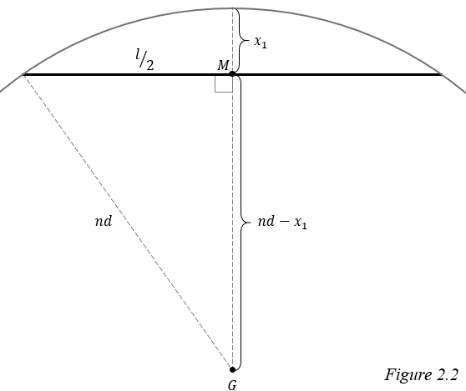In case 1, the needle lands in the outer half of the annulus, so the nearest circumference appears concave. This means there is a special case where the needle is close enough to always cross the circumference, regardless of $θ$. This is clear if we imagine the needle is a chord of a circle. In this scenario, the needle touches the circumference at every orientation.

We will call this critical distance at which this special case occurs $x_{1}$. If $x<x_{1}$, then the probability the needle crosses is 1. We can apply the Pythagorean theorem to solve for $x_{1}$:

$$\begin{aligned}{\left(nd-x_{1}\right)}^{2}+{\left(\frac{l}{2}\right)}^{2}={\left(nd\right)}^{2} \\ {\left(nd-x_{1}\right)}^{2}={\left(nd\right)}^{2}-{\left(\frac{l}{2}\right)}^{2} \\ nd-x_{1}=\sqrt{n^{2}d^{2}-\frac{l^{2}}{4}} \\ x_{1}=nd-\sqrt{n^{2}d^{2}-\frac{l^{2}}{4}} \#(2.4)\end{aligned}$$

Let $C_{n}$ be the event where a needle crosses a circumference when dropped in annulus $n$.

$$\begin{aligned}P\left(C_{n}∩ 0≤x<x_{1}|{ K}_{n}\right)=1∙P\left(0≤x<x_{1}|{ K}_{n}\right) \#\left(2.5\right)\end{aligned}$$

The right side is multiplied by 1 because as mentioned before, when $0≤x<x_{1}$, the probability the needle lands on the circumference is 1. The pdf of $x$ can be integrated to find the probability the needle falls in this range.

$$\begin{aligned}1∙P\left(0≤x<x_{1}\right)=1∙\int_{0}^{x_{1}}{\frac{8\left(nd-x\right)}{d^{2}\left(4n-1\right)}}dx\end{aligned}$$

$$=\frac{8}{d^{2}\left(4n-1\right)}\left(nd\left(x_{1}-0\right)-{\left.\left(\frac{x^{2}}{2}\right)\right|}_{0}^{x_{1}}\right)$$

$$=\frac{8}{d^{2}\left(4n-1\right)}\left(ndx_{1}-\frac{{x_{1}}^{2}}{2}\right)$$

Substituting $x_{1}$:

$$\frac{8}{d^{2}\left(4n-1\right)}\left[nd\left(nd-\sqrt{n^{2}d^{2}-\frac{l^{2}}{4}}\right)-\frac{{\left(nd-\sqrt{n^{2}d^{2}-\frac{l^{2}}{4}}\right)}^{2}}{2}\right]$$

$$=\frac{8}{d^{2}\left(4n-1\right)}\left[\frac{8nd\left(nd-\frac{\sqrt{{4n^{2}d^{2}-l}^{2}}}{2}\right)-{\left(2nd-\sqrt{{4n^{2}d^{2}-l}^{2}}\right)}^{2}}{8}\right]$$

Looking at the numerator in the brackets:

$$8nd\left(nd-\frac{\sqrt{{4n^{2}d^{2}-l}^{2}}}{2}\right)-{\left(2nd-\sqrt{{4n^{2}d^{2}-l}^{2}}\right)}^{2}$$

$$=\left(8n^{2}d^{2}-4nd\sqrt{{4n^{2}d^{2}-l}^{2}}\right)-\left(8n^{2}d^{2}-4nd\sqrt{{4n^{2}d^{2}-l}^{2}}-l^{2}\right)$$

$$=l^{2}$$

Substituting the numerator back in:

$$=\frac{8}{d^{2}\left(4n-1\right)}∙\left(\frac{l^{2}}{8}\right)$$

$$\begin{aligned}P\left(C_{n}∩ 0≤x<x_{1}|{ K}_{n}\right)=\frac{l^{2}}{d^{2}\left(4n-1\right)} \#\left(2.6\right)\end{aligned}$$

### **Case 1b**

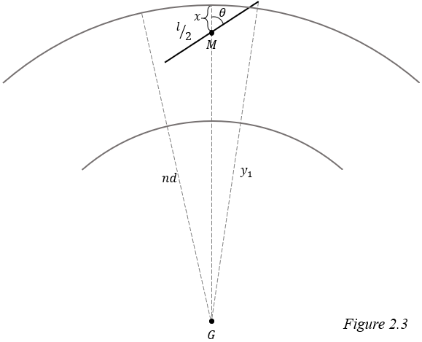Now let us address the scenario where the needle lands outside the critical distance, but still can cross the circumference, $x_{1}<x<l/2$. In this scenario we must also consider $θ$.

To determine whether the needle crosses, we will use the distance from $G$ to the farther endpoint of the needle, call this $y_{1}$. If $y_{1}>nd$ it signifies that the end of the needle is farther from the center of the circle than the circumference. Also, because we are assuming the needle falls within the $n$ th annulus, $\overline{GM}<nd$, so if $y_{1}>nd$, we can conclude the needle has crossed the line. Using the law of cosines to solve for $y_{1}$:

$$\begin{aligned}{y_{1}}^{2}={\left(\frac{l}{2}\right)}^{2}+{\left(nd-x\right)}^{2}-2\left(\frac{l}{2}\right)\left(nd-x\right)\cos\left(π-θ\right)\end{aligned}$$

Applying the identity $\cos\left(π-θ\right) =-\cos{θ}$ and simplifying:

$$y_{1}=±\sqrt{\frac{l^{2}}{4}+{\left(nd-x\right)}^{2}+l\left(nd-x\right)\cos{θ}}$$

We can ignore the negative root because lengths are always positive. Upon substituting $y_{1}$, we have the inequality that must be satisfied for the needle to cross:

$$\sqrt{\frac{l^{2}}{4}+{\left(nd-x\right)}^{2}+l\left(nd-x\right)\cos{θ}}>nd$$

Isolating $θ$:

$$\frac{l^{2}}{4}+{\left(nd-x\right)}^{2}+l\left(nd-x\right)\cos{θ}>{\left(nd\right)}^{2}$$

$$\cos{θ}>\frac{n^{2}d^{2}-\frac{l^{2}}{4}-{\left(nd-x\right)}^{2}}{l\left(nd-x\right)}$$

$${-cos}^{-1}\left(\frac{n^{2}d^{2}-\frac{l^{2}}{4}-{\left(nd-x\right)}^{2}}{l\left(nd-x\right)}\right)<θ<\cos^{-1}\left(\frac{n^{2}d^{2}-\frac{l^{2}}{4}-{\left(nd-x\right)}^{2}}{l\left(nd-x\right)}\right)$$

Remember, $0≤θ≤π/2$ so we can ignore the cases where $θ<0$:

$$\begin{aligned}θ<\cos^{-1}\left(\frac{n^{2}d^{2}-\frac{l^{2}}{4}-{\left(nd-x\right)}^{2}}{l\left(nd-x\right)}\right) , x_{1}≤x<l/2 \#\left(2.7\right)\end{aligned}$$

Call the right side of this inequality $α_{1}$. In case 1b, the needle will cross if $θ<α_{1}$.

$$\begin{aligned}P\left(C_{n}∩x_{1}≤x<l/2|{ K}_{n}\right)=P\left(θ<a_{1}∩x_{1}≤x<l/2 |{ K}_{n}\right) \#\left(2.8\right)\end{aligned}$$

The joint pdf of $θ$ and $x$ is necessary to solve $(2.8)$. These variables are independent so we can multiply their pdfs to find the joint pdf.

$$\begin{aligned}f\left(θ,x\right)=f\left(θ\right)∙f\left(x\right)\end{aligned}$$

$$=\frac{2}{π}∙\frac{8\left(nd-x\right)}{d^{2}\left(4n-1\right)}$$

$$\begin{aligned}=\frac{16\left(nd-x\right)}{{πd}^{2}\left(4n-1\right)} \#\left(2.9\right)\end{aligned}$$

We use iterated integrals to solve for the probability because the joint pdf considers both $θ$ and $x$. The inner integral integrates with respect to $θ$, and is bounded by 0 and $α_{1}$ since $θ$ must fall between those values for a cross. Likewise, the outer integral integrates with respect to $x$ and is bounded by $x_{1}$ and $l/2$.

$$\begin{aligned}P\left(x_{1}≤x<\frac{l}{2} ∩ θ<α\right)=\int_{x_{1}}^{\frac{l}{2}}{\int_{0}^{α_{1}}{\frac{16\left(nd-x\right)}{{πd}^{2}\left(4n-1\right)}}dθ}dx\end{aligned}$$

$$=\int_{x_{1}}^{\frac{l}{2}}{\frac{16\left(nd-x\right)}{{πd}^{2}\left(4n-1\right)}\left(a_{1}-0\right)}dx$$

Substituting $α_{1}$:

$$\begin{aligned}P\left(C_{n}∩x_{1}≤x<l/2|{ K}_{n}\right)= \\ \frac{16}{{πd}^{2}\left(4n-1\right)}∙\int_{x_{1}}^{\frac{l}{2}}{\left(nd-x\right)∙\cos^{-1}\left(\frac{n^{2}d^{2}-\frac{l^{2}}{4}-{\left(nd-x\right)}^{2}}{l\left(nd-x\right)}\right) }dx \#\left(2.10\right)\end{aligned}$$

To solve for the probability that a needle crosses a circumference given that it lands in the outer half of annulus $n$ we combine $(2.6)$ and $(2.10)$:

$$\begin{aligned}P\left(C_{n} |{ K}_{n}\right)=P\left(C_{n}∩ 0≤x<x_{1}|{ K}_{n}\right)+P\left(C_{n}∩x_{1}≤x<l/2|{ K}_{n}\right)\end{aligned}$$

$$=\frac{l^{2}}{d^{2}\left(4n-1\right)}+\frac{16}{{πd}^{2}\left(4n-1\right)}∙\int_{x_{1}}^{\frac{l}{2}}{\left(nd-x\right)∙\cos^{-1}\left(\frac{n^{2}d^{2}-\frac{l^{2}}{4}-{\left(nd-x\right)}^{2}}{l\left(nd-x\right)}\right) }dx$$

The calculations of the integral are quite laborious and involved, even running *Wolfram Mathematica* for hours did not yield any results. According to Khamis,[3] this equation can be simplified to:

$$\begin{aligned}P\left(C_{n} |{ K}_{n}\right)=\frac{4}{{πd}^{2}\left(4n-1\right)}∙\left(l\sqrt{n^{2}d^{2}-\frac{l^{2}}{4}}+2n^{2}d^{2}\sin^{-1}\left(\frac{l}{2nd}\right)\right) \#\left(2.11\right)\end{aligned}$$

## Case 2

The pdf of $x$ in case 2 differs from case 1 because $x$ is now the distance from $M$ to the inner circumference. To find the pdf of $x$, just as we did in case 1, we first find the cdf of $x$ by dividing the area where the needle is less than $x$ from the ${\left(n-1\right)}^{th}$ circumference by the total area of the inner half of the $n^{th}$ annulus.

$$\begin{aligned}F\left(x\right)=\frac{π{\left(\left(n-1\right)d+x\right)}^{2}-π{\left(n-1\right)d}^{2}}{π{\left[\left(n-\frac{1}{2}\right)d\right]}^{2}-π{\left(n-1\right)d}^{2}}\end{aligned}$$

Set $r=\left(n-1\right)d$:

$$\begin{aligned}=\frac{{\left(r+x\right)}^{2}-r^{2}}{{\left[\left(n-\frac{1}{2}\right)d\right]}^{2}-r^{2}} \#\left(2.12\right)\end{aligned}$$

Then we differentiate to find $f(x)$:

$$\begin{aligned}f\left(x\right)=\frac{d}{dx}\left(\frac{{\left(r+x\right)}^{2}-r^{2}}{{\left[\left(n-\frac{1}{2}\right)d\right]}^{2}-r^{2}}\right)\end{aligned}$$

$$=\frac{1}{d^{2}\left[{\left(n-\frac{1}{2}\right)}^{2}-{\left(n-1\right)}^{2}\right]}∙\left(2\left(r+x\right)∙1-0\right)$$

$$\begin{aligned}f\left(x\right)=\frac{2\left(r+x\right)}{d^{2}\left(n-\frac{3}{4}\right)}, 0≤x≤\frac{d}{2} \#\left(2.13\right)\end{aligned}$$

The pdf of $θ$ remains the same, and we can find the joint pdf of $θ$ and $x$ the same way:

$$\begin{aligned}f\left(θ,x\right)=f\left(θ\right)∙f\left(x\right)\end{aligned}$$

$$=\frac{2}{π}∙\frac{2\left(r+x\right)}{d^{2}\left(n-\frac{3}{4}\right)}$$

$$\begin{aligned}f\left(θ,x\right)=\frac{4\left(r+x\right)}{πd^{2}\left(n-\frac{3}{4}\right)} \#\left(2.14\right)\end{aligned}$$

### Case 2a

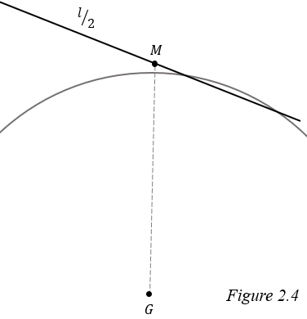In case 1, we compared the distance between $G$ and the farther endpoint of the needle to the distance between $G$ and the $n^{th}$ circumference to find the conditions for a success. This method can be reapplied to case 2, but there is a special case where it fails. Because the needle now lands on the inner half of the annulus, the nearest circumference appears convex. This means it is possible for both endpoints to be outside of the ${\left(n-1\right)}^{th}$ circumference, but still have the needle cross as is shown in *figure 2.4*.

To find where this case occurs, call the maximum value of $x$ at which the needle can be tangent to the ${\left(n-1\right)}^{th}$ circumference $x_{2}$. The radius of a circle forms a right angle with a tangent line so we can apply the Pythagorean theorem.

$$\begin{aligned}{\left(x_{2}+\left(n-1\right)d\right)}^{2}={\left(\frac{l}{2}\right)}^{2}+{\left(\left(n-1\right)d\right)}^{2}\end{aligned}$$

$$x_{2}+r=\sqrt{{\left(\frac{l}{2}\right)}^{2}+r^{2}}$$

$$\begin{aligned}x_{2}=\sqrt{\frac{l^{2}}{4}+r^{2}}-r \#\left(2.15\right)\end{aligned}$$

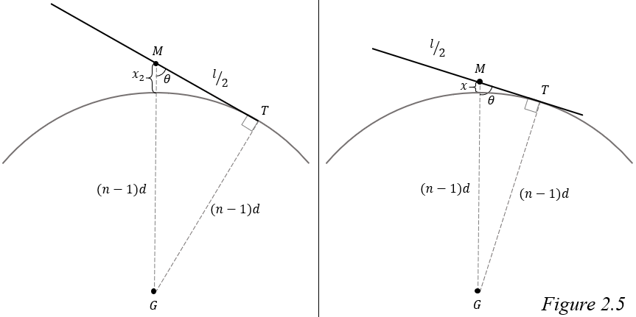When $x=x_{2}$ and the needle is tangent to the ${\left(n-1\right)}^{th}$ circumference, its endpoint touches the circumference, but when $x<x_{2}$ and the needle is tangent, some other point along the needle contacts the circle, call this point $T$.

As seen on the right in *figure 2.5*, $△MTG$ is a right triangle so we can find the value of $θ$ such that the needle is tangent to the circle at $T$.

$$\begin{aligned}\sin{θ}=\frac{r}{r+x}\end{aligned}$$

$$\begin{aligned}θ=\sin^{-1}{\begin{aligned}\left(\frac{r}{r+x}\right) \#\end{aligned}}\end{aligned}$$

At this value of $θ$, the needle touches the circumference at exactly one point, so if $θ$ were to get smaller by any amount, the needle would no longer be tangent and would cross the circumference.

$$\begin{aligned}θ<\sin^{-1}\left(\frac{r}{r+x}\right)\#\left(2.13\right)\end{aligned}$$

Call the right side of this inequality $α_{2a}$.

Just as we did in case 1, we can use an iterated integral to find the probability a needle crosses in this special case:

$$\begin{aligned}P\left(C_{n}∩0<x<x_{2} | {K^{'}}_{n}\right)=P\left(θ<α_{2a}∩0<x<x_{2} | {K^{'}}_{n}\right)\end{aligned}$$

$$=\int_{0}^{x_{2}}{\int_{0}^{α_{2a}}{\frac{4\left(x+r\right)}{πd^{2}\left(n-\frac{3}{4}\right)}}dθ}dx$$

$$=\int_{0}^{x_{2}}{\frac{4\left(x+r\right)}{πd^{2}\left(n-\frac{3}{4}\right)}\left(α_{2a}-0\right)}dx$$

$$=\frac{4}{πd^{2}\left(n-\frac{3}{4}\right)}∙\int_{0}^{x_{2}}{\left(r+x\right)∙\sin^{-1}\left(\frac{r}{r+x}\right)}dx$$

We come across an integral much like the one in case 1. The answer here is:[4]

### Case 2b

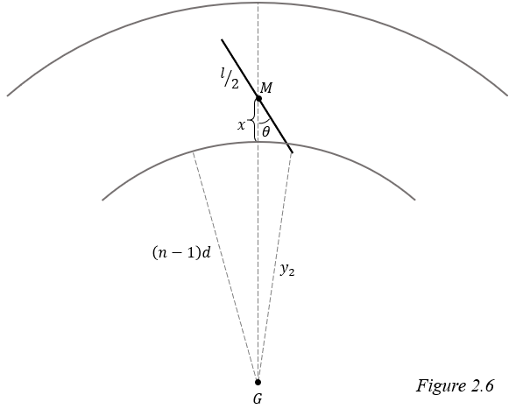When $x_{2}≤x<l/2$, the needle will only cross if its near endpoint is closer to the center than the circumference, so it can be solved in a similar manner as case 1b.

Call the distance from $G$ to the closer endpoint $y_{2}$. If $y_{2}<r$, then the needle has crossed the circumference. Applying the law of cosines to find $y_{2}$:

$$\begin{aligned}{y_{2}}^{2}={\left(\frac{l}{2}\right)}^{2}+{\left(r+x\right)}^{2}-2\left(\frac{l}{2}\right)\left(r+x\right)\cos{θ}\end{aligned}$$

$$y_{2}=±\sqrt{\frac{l^{2}}{4}+{\left(r+x\right)}^{2}-l\left(r+x\right)\cos{θ}}$$

Lengths are always positive, so we ignore the negative root and substitute:

$$\sqrt{\frac{l^{2}}{4}+{\left(r+x\right)}^{2}-l\left(r+x\right)\cos{θ}}<r$$

Isolating $θ$:

$$\frac{l^{2}}{4}+{\left(r+x\right)}^{2}-l\left(r+x\right)\cos{θ}<r^{2}$$

$$\cos{θ}>\frac{\frac{l^{2}}{4}+{\left(r+x\right)}^{2}{-r}^{2}}{l\left(r+x\right)}$$

$$\begin{aligned}θ<\cos^{-1}\left(\frac{\frac{l^{2}}{4}+{\left(r+x\right)}^{2}{-r}^{2}}{l\left(r+x\right)}\right) , x_{2}<x<\frac{l}{2} \#\left(2.18\right)\end{aligned}$$

Call the right side of this inequality $α_{2b}$.

Again, we integrate to find the probability a needle crosses when $x_{2}<x<l/2$ and the needle falls in the inner half of the annulus:

$$\begin{aligned}P\left(C_{n}∩x_{2}≤x< \frac{l}{2}| {K^{'}}_{n}\right)=P\left(θ<α_{2b}∩x_{2}≤x< \frac{l}{2} | {K^{'}}_{n}\right)\end{aligned}$$

$$=\int_{x_{2}}^{\frac{l}{2}}{\int_{0}^{α_{2b}}{\frac{4\left(r+x\right)}{πd^{2}\left(n-\frac{3}{4}\right)}}dθ}dx$$

$$=\int_{x_{2}}^{\frac{l}{2}}{\frac{4\left(r+x\right)}{πd^{2}\left(n-\frac{3}{4}\right)}\left(α_{2b}-0\right)}dx$$

Substituting $α_{2b}$:

$$=\frac{4}{πd^{2}\left(n-\frac{3}{4}\right)}∙\int_{x_{2}}^{\frac{l}{2}}{\left(r+x\right)∙\cos^{-1}\left(\frac{\frac{l^{2}}{4}+{\left(r+x\right)}^{2}{-r}^{2}}{l\left(r+x\right)}\right)}dx$$

The answer to this final integral is:[5]

We can now solve for the probability of a cross when the needle falls in the inner half of the annulus by combining $(2.17)$ and $(2.19):$

$$\begin{aligned}P\left(C_{n}| {K^{'}}_{n}\right)=P\left(C_{n}∩x_{2}≤x< \frac{l}{2}| {K^{'}}_{n}\right)+P\left(C_{n}∩0<x<x_{2} | {K^{'}}_{n}\right)\end{aligned}$$

$$=\frac{1}{πd^{2}\left(n-\frac{3}{4}\right)}∙\left(r\left(l+πr\right)-\frac{4r^{2}+l^{2}}{2}∙\cos^{-1}\left(\frac{l}{\sqrt{4r^{2}+l^{2}}}\right)\right)+$$

$$\frac{1}{πd^{2}\left(n-\frac{3}{4}\right)}∙\left(r\left(l-πr\right)+\frac{4r^{2}+l^{2}}{2}∙\cos^{-1}\left(\frac{l}{\sqrt{4r^{2}+l^{2}}}\right)\right)$$

$$=\frac{1}{πd^{2}\left(n-\frac{3}{4}\right)}∙$$

$$\left(r\left(l+πr\right)-\frac{4r^{2}+l^{2}}{2}∙\cos^{-1}\left(\frac{l}{\sqrt{4r^{2}+l^{2}}}\right)+r\left(l-πr\right)+\frac{4r^{2}+l^{2}}{2}∙\cos^{-1}\left(\frac{l}{\sqrt{4r^{2}+l^{2}}}\right)\right)$$

$$=\frac{r\left(l+πr\right)+r\left(l-πr\right)}{πd^{2}\left(n-\frac{3}{4}\right)}$$

$$=\frac{2lr}{πd^{2}\left(n-\frac{3}{4}\right)}$$

Substituting $\left(n-1\right)d$ for $r$:

$$=\frac{2l\left[\left(n-1\right)d\right]}{πd^{2}\left(n-\frac{3}{4}\right)}$$

$$\begin{aligned}P\left(C_{n}| {K^{'}}_{n}\right)=\frac{2l\left(n-1\right)}{πd\left(n-\frac{3}{4}\right)} \#\left(2.20\right)\end{aligned}$$

## Solution

Now that we know the probability of a cross when the needle lands in either the inner or outer half of annulus $n$, we must find the probability that the needle lands in each of these halves. This is done by dividing the area of the respective portion of the annulus by the area of the $N$ th circle.

$$\begin{aligned}P\left(K_{n}\right)=\frac{π{\left(nd\right)}^{2}-π{\left[\left(n-\frac{1}{2}\right)d\right]}^{2}}{π{\left(Nd\right)}^{2}}\end{aligned}$$

$$=\frac{n^{2}d^{2}-{\left(n-\frac{1}{2}\right)}^{2}d^{2}}{N^{2}d^{2}}$$

$$P\left(K_{n}\right)=\frac{n-\frac{1}{4}}{N^{2}}$$

$$P\left({K'}_{n}\right)=\frac{π{\left[\left(n-\frac{1}{2}\right)d\right]}^{2}-π{\left[\left(n-1\right)d\right]}^{2}}{π{\left(Nd\right)}^{2}}$$

$$=\frac{{\left(n-\frac{1}{2}\right)}^{2}d^{2}-{\left(n-1\right)}^{2}d^{2}}{N^{2}d^{2}}$$

$$\begin{aligned}P\left({K^{'}}_{n}\right)=\frac{n-\frac{3}{4}}{N^{2}} \#\left(2.21\right)\end{aligned}$$

Call $C_{N}$ the event where a needle crosses a circumference when dropped on $N$ concentric circles. We can now take our solutions, which apply only to a specific annulus, and generalize them to account for all annuli using the law of total probability. All possible locations of $M$ fall somewhere within the $N$ th circle which we will partition into the inner and outer halves of each annulus. We can then sum the probabilities that the needle crosses the nearest circumference and lands in the inner half of the $n$ th annulus for all $N$ annuli. Doing the same with the outer half of the $n$ th annulus and adding the two sums together provides the probability that the needle crosses any circumference, $P\left(C_{N}\right)$.

$$\begin{aligned}P\left(C_{N}\right)=\sum_{n=1}^{N}{P\left(C_{n}∩ K_{n}\right)}+\sum_{n=2}^{N}{P\left(C_{n}∩{K^{'}}_{n}\right)}\end{aligned}$$

This can be rewritten:

$$\begin{aligned}P\left(C_{N}\right)=\sum_{n=1}^{N}{P\left(C_{n}| K_{n}\right)}∙P\left(K_{n}\right)+\sum_{n=2}^{N}{P\left(C_{n}| {K^{'}}_{n}\right)}∙P\left({K^{'}}_{n}\right)\end{aligned}$$

Left term:

$$\sum_{n=1}^{N}{\frac{4}{{πd}^{2}\left(4n-1\right)}∙\left(l\sqrt{n^{2}d^{2}-\frac{l^{2}}{4}}+2n^{2}d^{2}\sin^{-1}\left(\frac{l}{2nd}\right)\right)∙\frac{n-\frac{1}{4}}{N^{2}}}$$

$$=\frac{1}{{πd}^{2}N^{2}}∙\sum_{n=1}^{N}{\left(l\sqrt{n^{2}d^{2}-\frac{l^{2}}{4}}+2n^{2}d^{2}\sin^{-1}\left(\frac{l}{2nd}\right)\right)}$$

Right term:

$$\sum_{n=2}^{N}{\frac{2l\left(n-1\right)}{πd\left(n-\frac{3}{4}\right)}}∙\frac{n-\frac{3}{4}}{N^{2}}$$

$$=\frac{2l}{πdN^{2}}\sum_{n=2}^{N}{n-1}$$

$$=\frac{2l}{πdN^{2}}\left(\sum_{n=1}^{N}{\left(n-1\right)}-\sum_{n=1}^{1}{\left(n-1\right)}\right)$$

$$=\frac{2l}{πdN^{2}}\left(\sum_{n=1}^{N}{n}-\sum_{n=1}^{N}{1}\right)$$

$$=\frac{2l}{πdN^{2}}\left(\frac{N}{2}\left(N+1\right)-N\right)$$

$$=\frac{2l}{πdN^{2}}\left(\frac{N^{2}}{2}-\frac{N}{2}\right)$$

$$=\frac{l\left(N-1\right)}{πdN}$$

The final solution:

$$\begin{aligned}P\left(C_{N}\right)=\frac{1}{{πd}^{2}N^{2}}∙\sum_{n=1}^{N}{\left(l\sqrt{n^{2}d^{2}-\frac{l^{2}}{4}}+2n^{2}d^{2}\sin^{-1}\left(\frac{l}{2nd}\right)\right)}+\frac{l\left(N-1\right)}{πdN} \#\left(2.22\right)\end{aligned}$$

This is the probability that a needle of length $l$ will cross a circumference when randomly dropped on a set of $N$ concentric circles, each spaced a distance $d$ apart, and $l<d$.

# Works Cited

Aigner, Martin, and Günter M Ziegler. *Proofs from THE BOOK*. Springer-Verlag, 2004.

Khamis, Harry J. “On Buffon’s Needle Problem Using Concentric Circles.” *Pi Mu Epsilon Journal*, vol. 8, no. 6, 1987, pp. 368-374. *Pi Mu Epsilon*, http://www.pme-math.org/journal/issues.html

1. Aigner, Martin, and Günter M Ziegler. Proofs from THE BOOK. Springer-Verlag, 2004.
2. Khamis, Harry J. “On Buffon’s Needle Problem Using Concentric Circles.” *Pi Mu Epsilon Journal*, vol. 8, no. 6, 1987, pp. 368-374. *Pi Mu Epsilon*, http://www.pme-math.org/journal/issues.html
3. Khamis p. 371
4. Khamis p. 373
5. Khamis p. 374